

**THE UNIVERSITY OF THE WEST INDIES**

**Mona Campus**

Semester l Semester II □ Supplemental/Summer School □

**Mid-Semester Examinations of: October /February/March** □ **/June** □ **2015/2016**

Course Code and Title: **COMP2201 Discrete Mathematics for Computer Scientists**

Date: **Friday, October 23, 2015** Time: **2:00 p.m.**

Duration: **1 Hour.** Paper No: **1 (of 1)**

Materials required:

**Answer booklet: Normal Special** □ **Not required** □

**Calculator: Programmable** □ **Non Programmable Not required** □

*(where applicable*)

**Multiple Choice answer sheets: numerical □ alphabetical □ 1-20 □ 1-100** □

Auxiliary/Other material(s) – Please specify: None

**Candidates are permitted to bring the following items to their desks: Pencil or pen, Ruler, ID card, Exam card**

**Instructions to Candidates: This paper has 2 pages & 6 questions.**

**Candidates are reminded that the examiners shall take into account the proper use of the English Language in determining the mark for each response.**

# All questions are COMPULSORY.

**Calculators are allowed.**

**MID-SEMESTER 1 2015/2016**

2

1. Consider the geometric series:

3 + 21/9 + 147/81 + 1029/729 + …

* 1. Determine a formula for Sn

where Sn is the sum of the first *n* terms of the series? **[4]**

The series is a Geometric Progression (GP)

a = 3

As a = 3

and ar = 21/9

(3)r = 21/9

r = (21/9)/3

= 21/27

For GP

Sn = a(rn-1) / (r-1)

= 3((21/27)n-1) / ((21/27)-1)

= 3((21/27)n-1) / (-(6/27))

= -81/6((21/27)n-1)

= -27/2((7/9)n-1)

* 1. What is the limit of Sn **[1]**

Where |r| < 1

Limit of Sn = a / (1-r)

= 3 / (1 - (21/27))

= 3 / (6/27)

= 81/6

= 27/2

1. (a) Consider selections among non-distinct copies of an Adventure book, a Mystery book, a History book, a Comic, a Romance novel and an Educational book. Write the formula to determine the number of ways to

select any eight of these? **[1]**

**8+6-1C6-1**

(b) By using the inclusion-exclusion principle, give a formula for the

number of elements in the union of four sets *X1*, *X2*, *X3* and *X4*. **[2]**

**TODO: Change A B C D to X1 X2 X3 X4 lol**

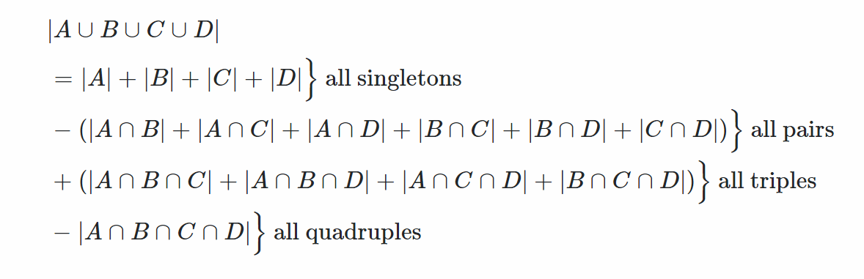

**.**

**=**

**-**

**+**

**-**

1. (a) In a given town only 2 percent of all citizens will vote in every national elections that is held. Find the probability that among 150 citizens in that

town, at least four of them will vote in the next national elections. **[3]**

Using Binomial

. $b\left(x;n,θ\right)=C_{x}^{n} θ^{x}({1-θ)}^{n-x}$ for x = 0,1,2,…,n

. $b\left(4;150,0.02\right)=C_{4}^{150} ×{0.02}^{4}×{0.98}^{150-4}$

. $=0.1697$

(b) If a student does not study at all for this COMP2201 Mid-term examination, the probability of passing the examination is 3%. If one studies at an average level, the probability of passing the examination is 51% whereas if study is done intensely, the probability of passing the COMP2201 Mid-term examination is 92%. The course lecturer is sure that 8% of students do not study at all, 67% of them study at an average level and 25% of them study intensely. Given that you pass this COMP2201 Mid-term examination, what

is the probability that you did not study **[3]**

**Let**

**N - Study None at all**

**L - Study at Average Level/ Studied Lightly**

**I - Studied Intensely**

**C - Passing the course COMP2201**

**Given**

**P(C|N) = 0.03**

**P(C|L) = 0.51**

**P(C|I) = 0.92**

**P(N) = 0.08**

**P(L) = 0.67**

**P(I) = 0.25**

**Required P(N|C)**

**P(N|C) = $\frac{P(C|N)P(N)}{P\left(C|N\right)P\left(N\right)+ P\left(C|L\right)P\left(L\right) + P\left(C|I\right)P\left(I\right)}$**

**= $\frac{(0.03)(0.08)}{\left(0.03\right)\left(0.08\right)+ \left(0.51\right)\left(0.67\right) + \left(0.92\right)\left(0.25\right)}$**

**= $\frac{0.0024}{0.0024 + 0.3417 + 0.23}$**

**= $\frac{0.0024}{0.5741}$**

**= 0.00418 or 0.004**

1. (a) If there are 62 successful GSAT students that were placed in 9 secondary institutions, use the Pigeonhole Principle to show that there is an institution

with at least seven of these GSAT students. **[3]**

Using the third form of the pigeonhole principle we have,

k = $\left\lceil \frac{n}{m}\right\rceil$, where n = 62 and m = 9

= $\left\lceil \frac{62}{9}\right\rceil$

= $\left\lceil 6.89\right\rceil$

= 7

**Therefore there exists an institution with at least 7 of these students.**

1. Use the Binomial Theorem to show that

*n*

5*k C*(*n*, *k*)  6*n*

*k* 0

We know that ${\left(a+b\right)}^{n}=\sum_{k=0}^{n}{C\left(n,k\right){a^{n-k}b}^{k}}$

We eliminate an-k and substitute values for the proof

Let a = 1, b = 5

So we have,

. $\sum_{k=0}^{n}{C\left(n,k\right){a^{n-k}b}^{k}}={\left(a+b\right)}^{n}$

. $\sum_{k=0}^{n}{C\left(n,k\right){1^{n-k}5}^{k}}={\left(1+5\right)}^{n}$

As 1x = 1 for x $∈Z$

Therefore,

. $\sum_{k=0}^{n}{5^{k}C\left(n,k\right)}=6^{n}$

1. Use Pascal’s triangle to compute the values of

# [3]

 6

8

  

*and*

  

3

 5

. =

=

= 20

. $\left({8 \atop 5}\right)$ = $\frac{8!}{5!\left(8-5\right)!}$**[2]**

= $\frac{40,320}{720}$

= 56

1. Consider the recurrence function

*T(n) = 16T(n/2) + 56n3*

Give an expression for the runtime *T(n)* if the recurrence can be solved

with the Master Theorem. Assume that *T(n) = 1* for *n ≤ 1*. **[4]**

1. Show that *2n + 4n + 6n + 8n + … + (n-2)n + n2* is of order *n3*. **[4]**

2n + 4n + 6n + 8n + … + (n-2)n + n2 ≤ n2 + n2 + n2 + n2 + … + n2

≤ n * n2

≤ n3

For all n ≥ 1.

Therefore 2n + 4n + 6n + 8n + … + (n-2)n + n2 = O(n3)

We may obtain a lower bound by examining the full series in relation to a portion of the series:

2n + 4n + 6n + 8n + … + (n-2)n + n2

≥

≥

≥

≥

≥

Hence,

2n + 4n + 6n + 8n + … + (n-2)n + n2 = Ω(n3)

Therefore,

2n + 4n + 6n + 8n + … + (n-2)n + n2 = Θ(n3)

**END OF QUESTION PAPER**

**Mid-Semester I 2015/2016**